**Steps to Create Requests for Server CPU / Mem**

1. Goto <https://jnjprod.service-now.com/iris> and click on “**IT Service Item Catalog**”

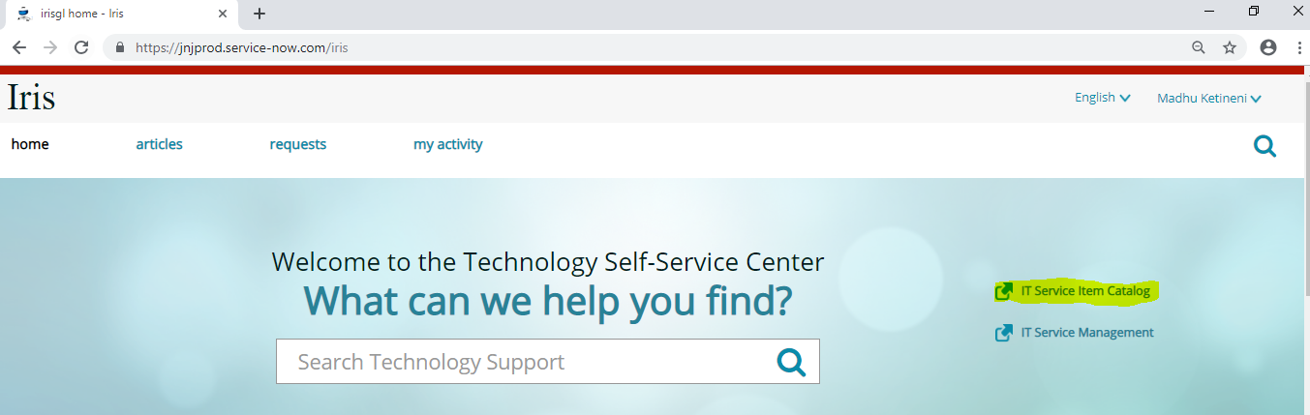

2. Select the tab “**Submit a request**” and click on “**Server provisioning and support**”

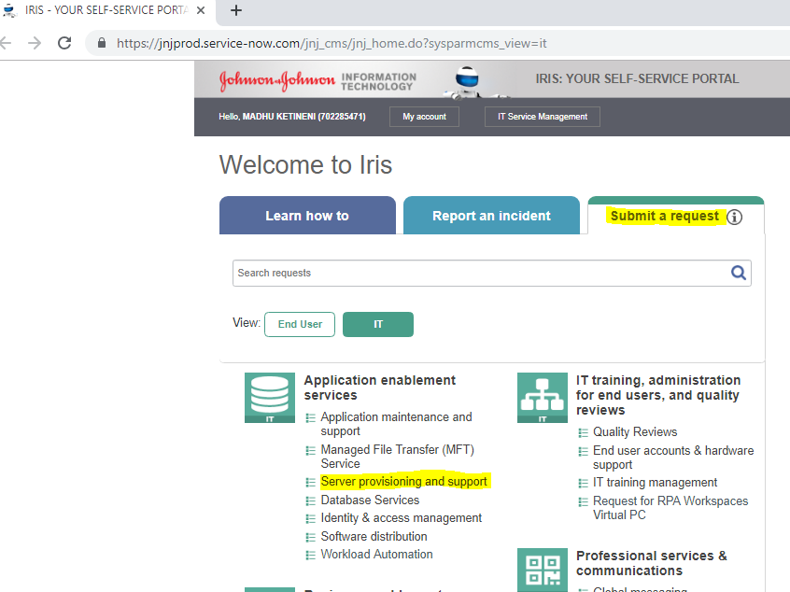

3. Click on “**Server Change and Maintenance**”

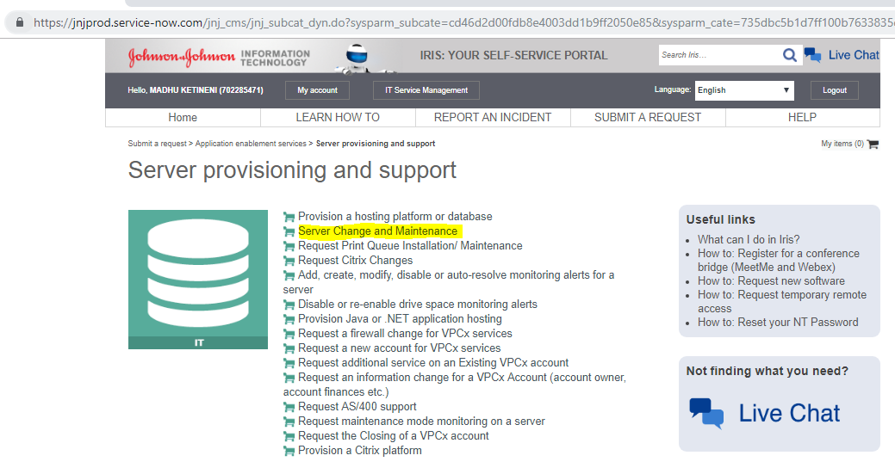

4. Select or enter the required information on the next screen as shown below.

* Select appropriate application associated with the server under “Select Application / Application Server”.
* Select the server on which the change/maintenance is required under “Select Server”.
* For Type of Activity select “**CPU/Memory Change**”.
* Select Maintenance start and end timing.
* In Business Reason (Justification) enter the required CPU/Memory.
* Enter Technical Impact.
* Select appropriate Business Impact.

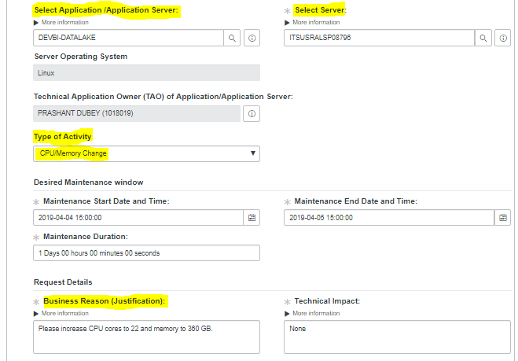

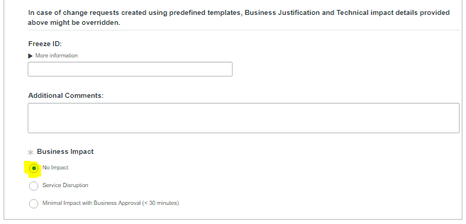

5. Click on “**Choose Options**” on the top right side of the screen

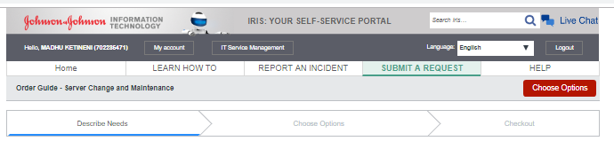

**6.** On the following screen under options check “Update CPU” and “Update Memory” boxes and enter the required values. If the required value is not there select the closest value and in justification enter the required values.

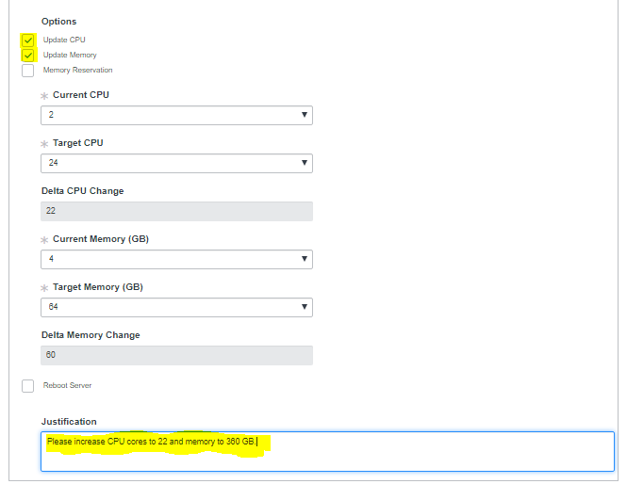

7. Click on “**Checkout**” on the top right side of the screen and the request will be submitted. Note down the Request number for reference.

